|  |  |  |  |  |  |
| --- | --- | --- | --- | --- | --- |
| Date | 28-Nov-22 | | | Tester Name | Janette Paus |
| Environment | Penfax - Test 2 | | | Login used |  |
| Operating System | Windows | Version: 21H2 | Update Number: | | |
| Software Used | Select Software | Version: 107.0.1418.56 | Update Number: | | |
| Select Software | Version: | Update Number: | | |
| Application Release version | R22.4.1 | | | | |
| Test Case Title | E 19.01 | | | | |
| Test Type | Regression | | | | |
| Test Scenario | Process Terminal Illness Payment (100% balance) | | | | |
| Expected Results | That the payment will process, and member profile status will not change after the payment has processed, there will be no funds remaining in the account and that it will be taxed properly, according to the 10/20/30 rule. | | | | |
| Pass/Fail | Pass | | | JIRA# |  |

SID 247509:

Choose member with Active Employment and a balance greater than zero:

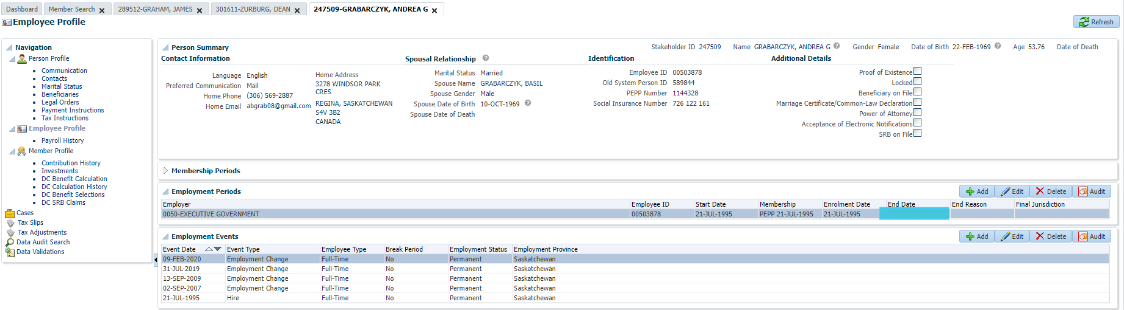

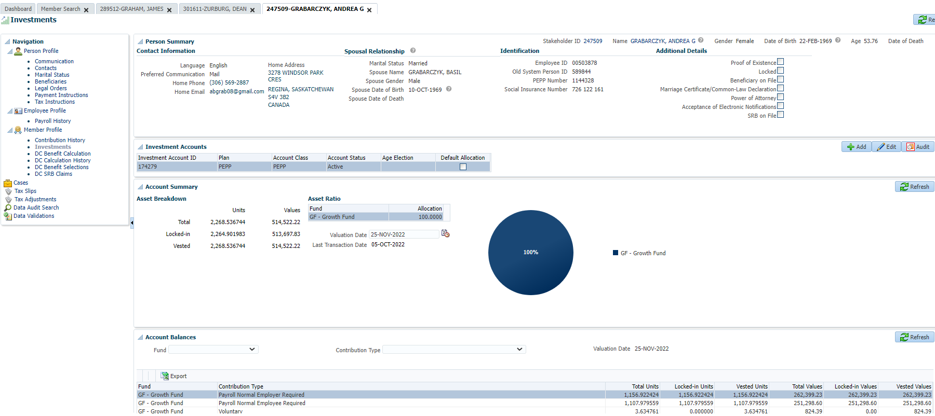

Under Investments, add an Account Instruction for Terminal Illness payment, select 100% of balance. Added Payment Instruction and left Tax Instruction blank, then clicked Save.

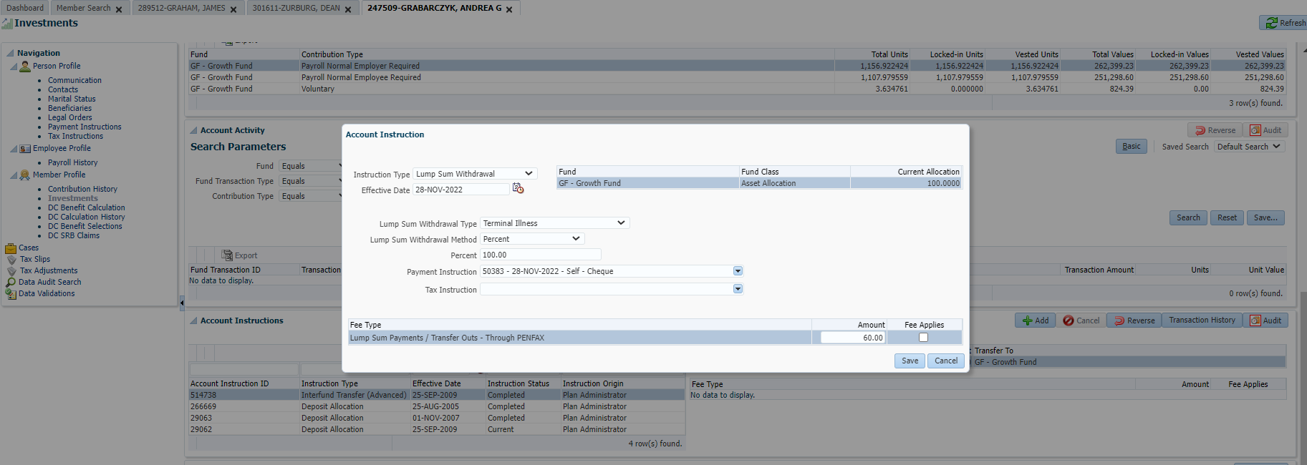

After PIT batch runs, check the payment is processed and the taxes are correct.

